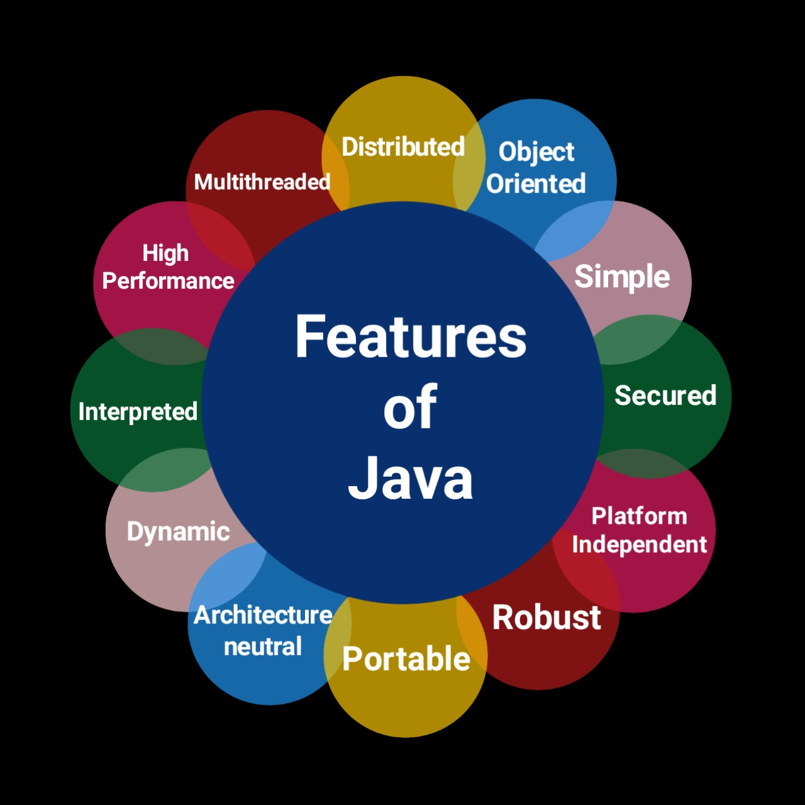

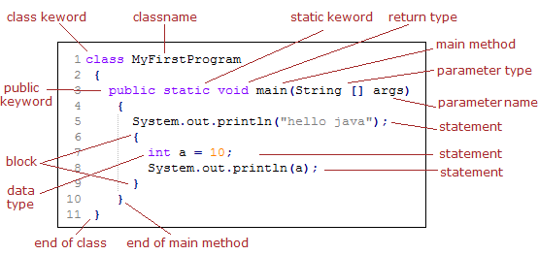

**Java development kit**

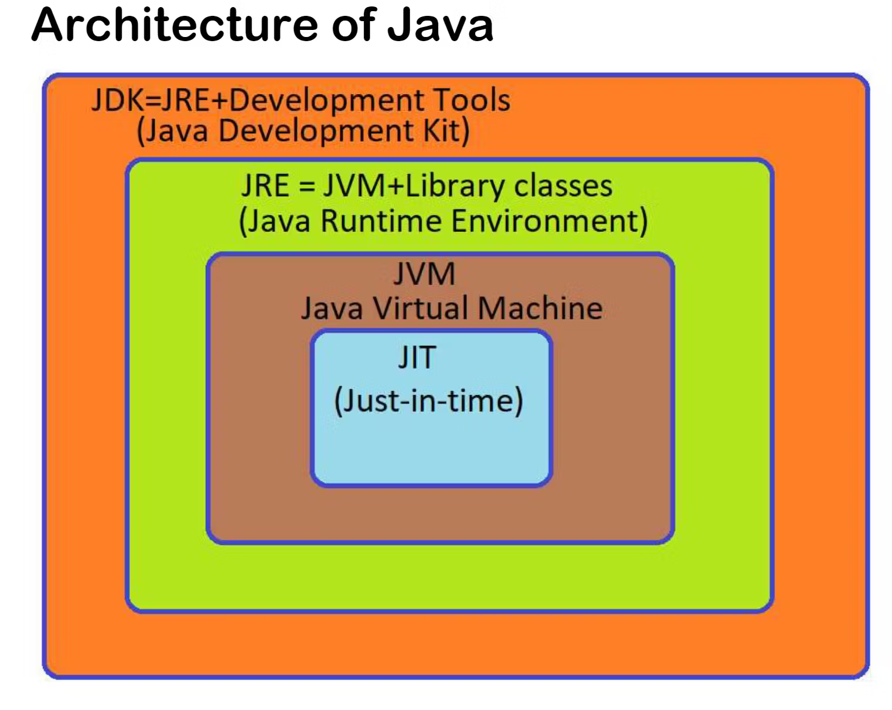

JDK - Java Development Kit.

JRE - Java Runtime Environment.

JVM - Java Virtual Machine.

JIT - Just in Time



public static void main(String[] args)

Public - access modifier

Static - keyword

Void - return type

Main - method name

String []args - parameters of string array type.

Variable - mutable

Constant - immutable

Three type of variable

Local variable - declared inside the method.or within the scope

Instance variable - inside in the class but outside the method.

Static variable - shared memory for all the resources.

Class A

{

Int x=10; // instance variable

Static y=11; // static variable

display()

{

Int z=12;//local variable

}

Rapper classes are Integer,character and String

INTEGER can upload the int but int can’t holds the INTEGER.

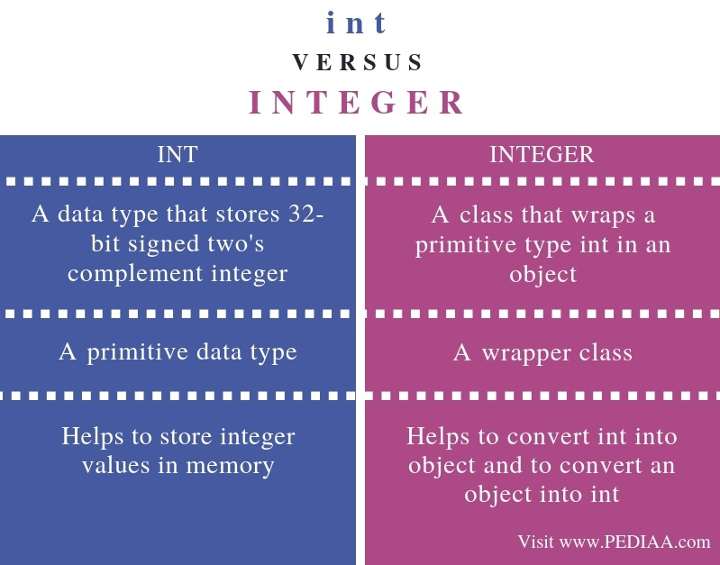

Classes

Classes have some data members and methods

# Java OOPs Concepts

An example of java class.





***Object are always made in main method.***



In a class , many method can be made in a class

Access modifier

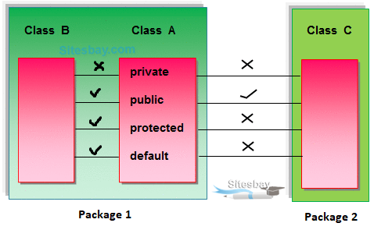



What is meant by code redundancy?

Code redundancy is defined as code that are in your source code, but are not required or have no logical effect to the output. It could be a block of code that is never executed, logic that never actually affects the output, or re-computation of a variable's value multiple times.

* Constructor

We dont call constructor while in method we are calling method

by using object name.method name();

Constructor are used is to initialize the value of a class,while creating a object.

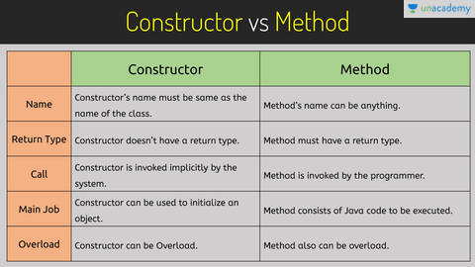



Static keywordIn Java, static keyword is mainly used for memory management. It can be used with variables, methods, blocks and nested classes. It is a keyword which is used to share the same variable or method of a given class

Every static field and methods are invoke in by class name.

Eg;-

class Student

{

int id;

String name;

Static String School name="ABC";

}

public void static display()

{

System.out.println("school");

}

public void show()

{

System.out.println("hello");

}

If i want to call school name

Student.schoolname; “ “ “ “” “” “ “ “

student .dispaly(); calling method where static is used

Que - Why static is used in main class method? (interview question)

Ans If we dont use static keyword than we have to make an object for the classes in the programmme.

Note :- One of the main work of class loader is to load all static keyword which are used in data member and method of a class.

This keyword What is this keyword?

The this keyword refers to the current object in a method or constructor. The most common use of the this keyword is to eliminate the confusion between class attributes and parameters with the same name

Basically this keyword refers the current object of the class/

Can access the data members and method from one constructor to another constructorr of a same class.

Student(int nid,string name)

{

this.id=id;

this.name=name;

}

Student sd=new Student(101,”amit”);

If same datatype of two constructor can nnot be make.

Inheritance - reusability

5 type of Inheritance

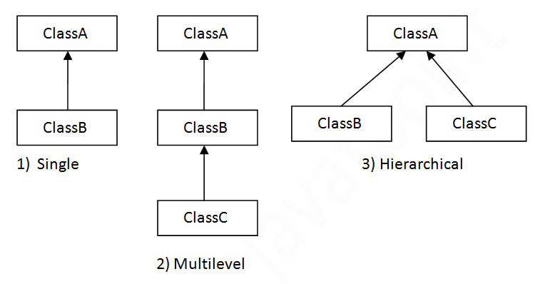

Q When static keyword is used in method how we can call it

Ans:- classname.fieldname();

Aggregation





Overloading

When in a some class you define multiple methods which are having same mathed name but either no of data types are their parameters are same with different datatypes or parameters are different with same data type.



Overriding

When you have a same method in different classes and those classes are achieving an inheritance is known as overriding.



Object hava characteristic and functionality;

And class are blueprint and a template which is used for object